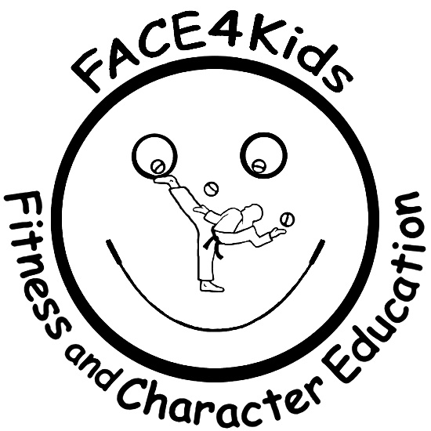

Fitness And Character Education
Graduation
Spring Park Elementary

Location: Spring Park Elementary – Cafeteria
Time: 9:30 – 10:15 am
Date: Wednesday May 18, 2022

Dear Parent(s),

Your child will be earning their recognition awards on Wednesday May 18, 2022. The graduation will be a normal class, with the last 10 minutes focused on both their public speaking and receiving their graduation certificates, jump rope and T-Shirt.

Please feel welcome to come and watch, with family members and/or cameras too. The class will be held in the Cafeteria.

Thank you as it has been a pleasure sharing the FACE4Kids experience with your child.

Kirk Farber
kirk@face4kids.org

