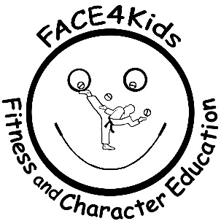

Fitness And Character Education, Inc. and Seabreeze Elementary are offering a youth leadership program. This dynamic program combines confidence, growth and positive attitude leaving an imprint that lasts a lifetime.

First _____________ Last ________________________ Grade ______

Please fill out below with name of child  
- - - - - - - - - - - - - - - - - - - - - - - - - - - - - - - - - -

Date

Signature of Parent/Guardian

Print Name

**I hereby grant permission for my child to participate in the**

**FACE program located at Seabreeze Elementary.   
  
 Thursdays, September 30, 2021 – November 18, 2021 9:40 – 10:25 am**

Name of Child: __________________________ Age: _____

Address: ____________________________________ Apt#: _____

Contact Phone / Email: ________________________________

**Fitness And Character Education (FACE)** **Permission to Participate Form – Program is at No Cost.**